**Software Requirements and Design Document**

**For**

**Group <24>**

Version 3.0

**Authors**:

Garett A

Daniel B

Cameron H

Jared U

# Overview

A retro futuristic, cyberpunk platformer. It features movement mechanics, enemies, and a boss battle featuring a ship. We were looking to make a unique modern take on the old retro style games similar to Megaman, blending the mechanics of a 2D platformer with a shooter.

# Functional Requirements

*1. Basic Player Movement - High*

*2. Advanced Player Movement - Medium*

*3. Basic Enemies and Enemy Logic - High*

*4. Player Attack - High*

*5. Player Abilities - Medium*

*6. A good map - Medium*

*One solid map that showcases what’s possible in terms of platforms and enemies. i.e configurations of platforms and enemies*

*7. Multiple maps - Low*

*8. Boss – Medium*

*A boss that has more complicated movement compared to basic enemies.*

*i.e. moves/attacks faster after being hit by the player*

*9. Multiple Bosses - Low*

*10. High Scores – Low*

*11. Remappable Controls – Low*

*12. Sound Effects – Medium*

*13. Soundtrack – Low*

*14. Settings and Title Screen – High*

# Non-functional Requirements

1. Computer needs to have python installed, as well as pygame

# Use Case Diagram

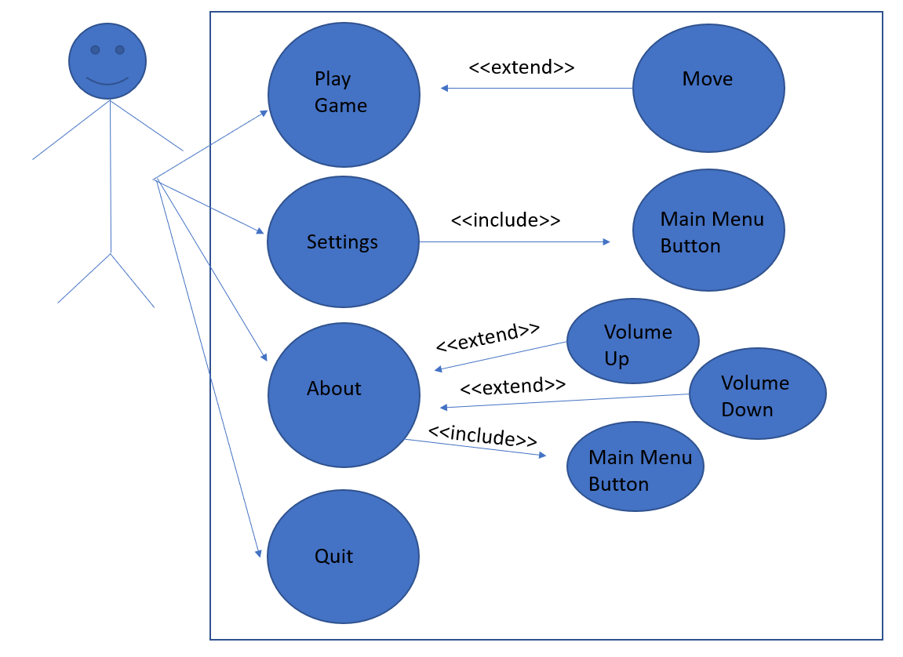

# Class Diagram and/or Sequence Diagrams

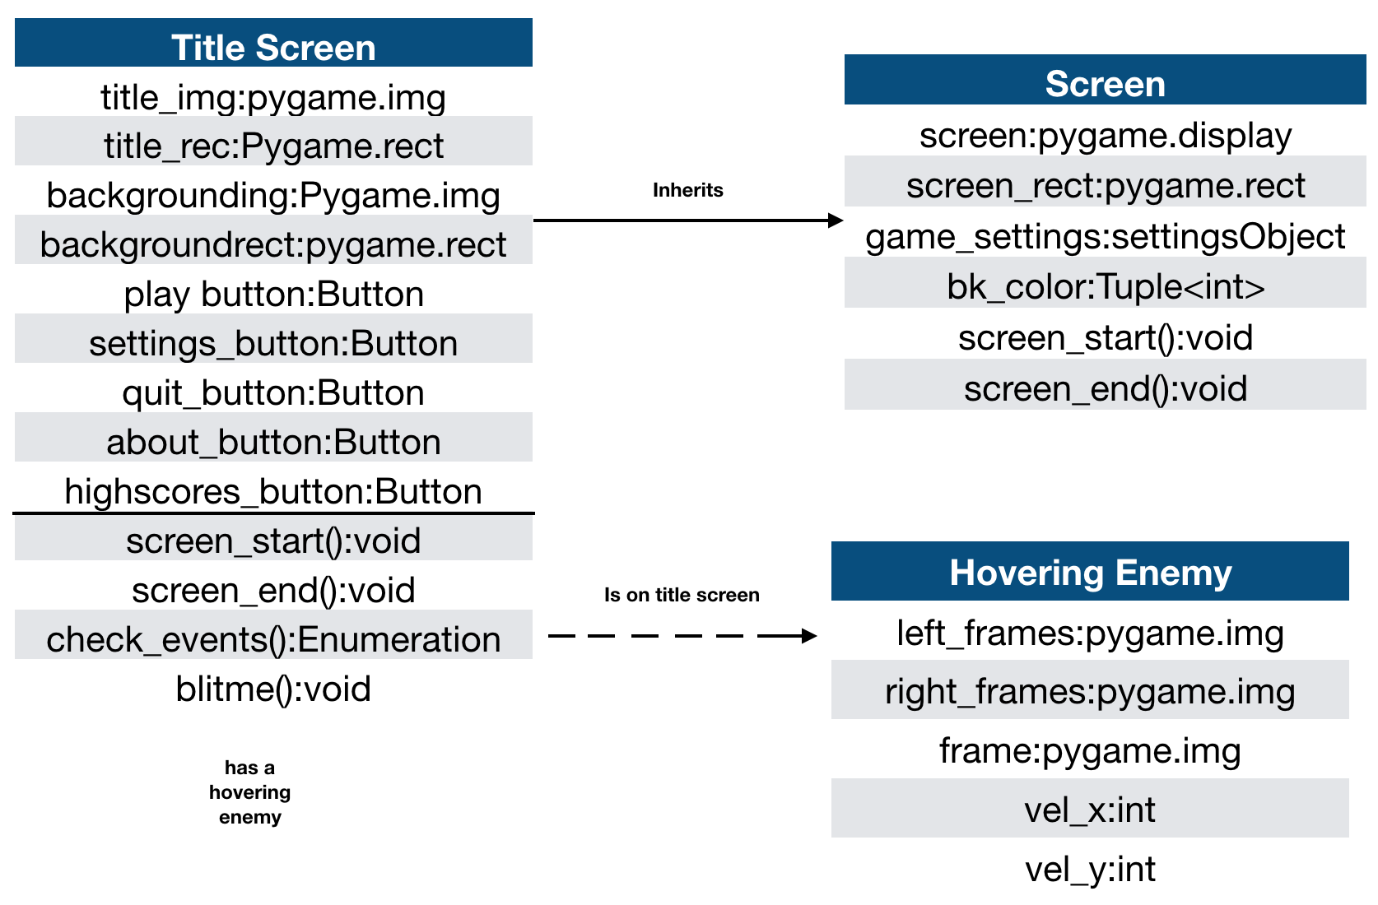

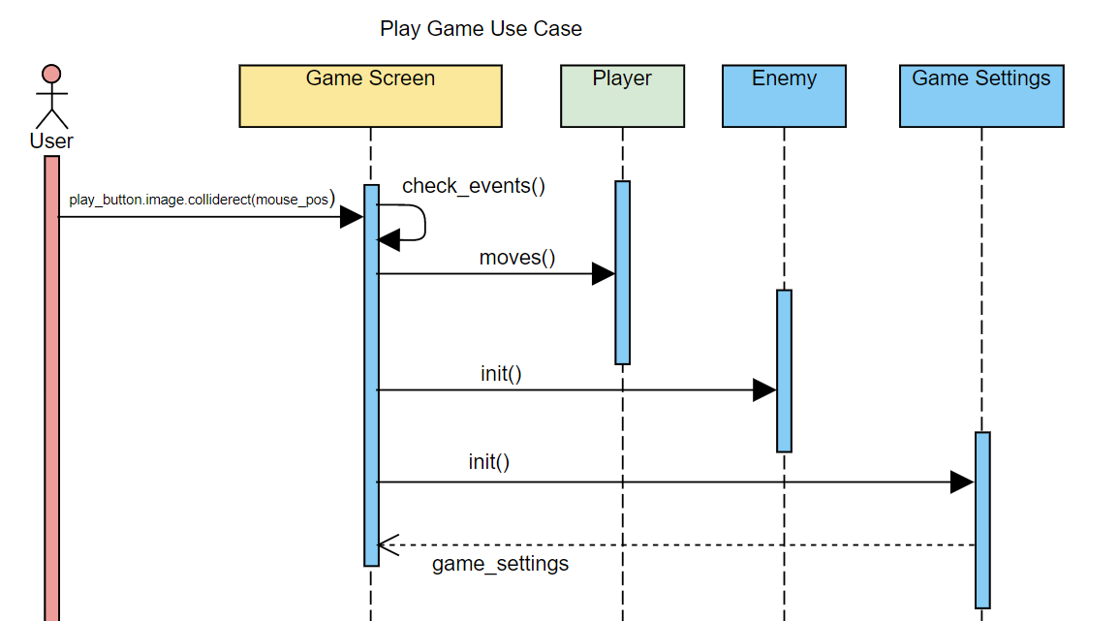

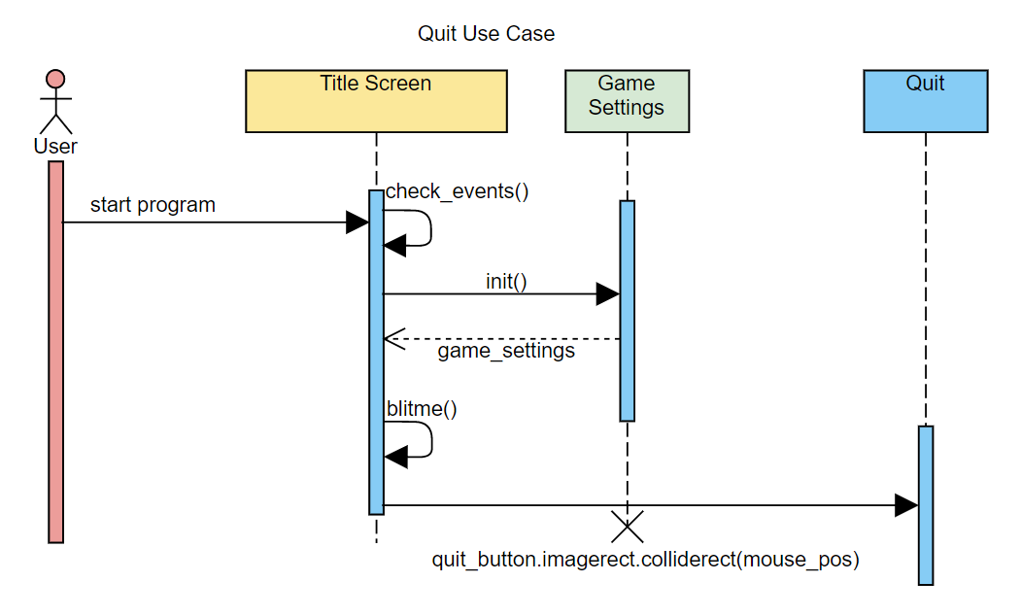

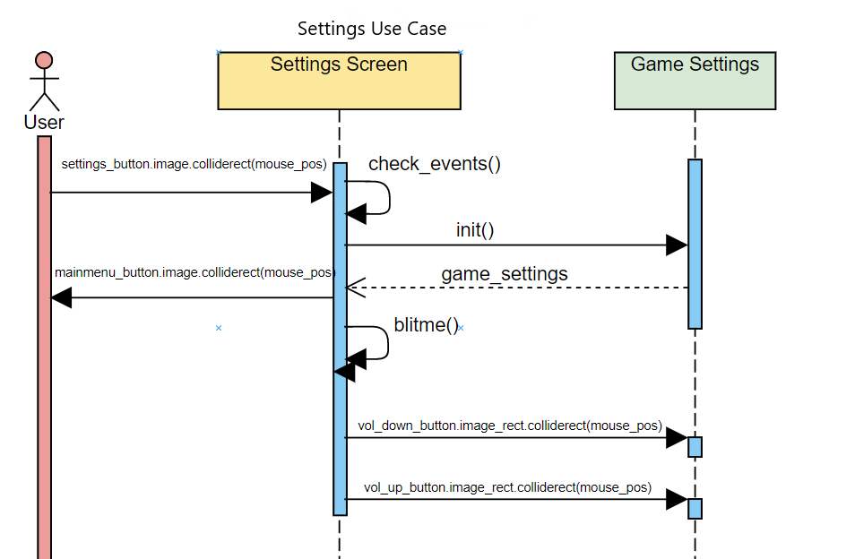

# Operating Environment

Any operating system compatible with python, computer must install python3 as well as the pygame library.

# Assumptions and Dependencies

We used free non copyrighted graphics and sounds downloaded from the internet. Since this is not essentially coding it isn’t relevant to the class project to have created these ourselves, so we used available ones which matched our vision of the project.